Digital Drawing Tools and Software

In today’s fast-paced design industry, digital tools have become indispensable for interior designers. The evolution from traditional hand-drawing to sophisticated digital software has not only streamlined the design process but also expanded creative possibilities. Whether for concept development, client presentations, technical drawings, or 3D visualizations, digital drawing tools allow designers to work more efficiently and with greater precision. This article provides an introduction to the most widely used digital tools and software in interior design, analyzing their features, advantages, disadvantages, and relevance within the industry.

# Types of tools used to draw digitally

Before diving into specific software, it's important to understand the hardware and devices that facilitate digital drawing in interior design. These tools serve as the physical interface between the designer and the digital workspace.

## Graphics Tablets

Graphics tablets allow designers to draw by hand with a stylus while their input appears on a computer screen.

Use in Interior Design: Sketching floor plans Annotating designs Freehand rendering

Pros:

Natural drawing experience

High pressure sensitivity and precision

Cons:

Requires hand-eye coordination

Usually needs to be paired with design software

Fig. 1 Designer working on a graphic tablet 

## Pen Displays (Display Tablets)

Unlike traditional graphics tablets, pen displays allow designers to draw directly on the screen.

Use in Interior Design:

Detailed hand-drawn illustrations and digital renderings Design annotations on plans

Pros:

More intuitive, direct drawing experience High accuracy and pressure sensitivity

Cons:

Can be expensive

Bulky setup for some workspaces

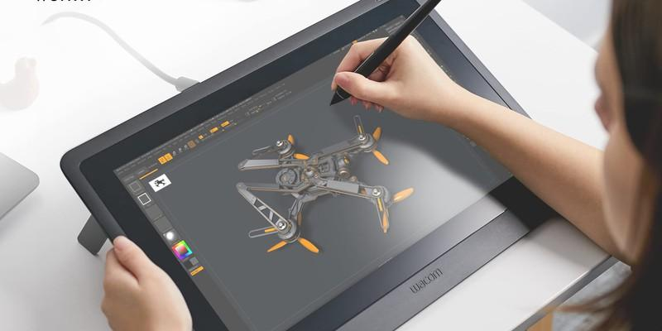

Fig 2. Astropad (nd), [Wacon Tablet](https://astropad.com/blog/pen-tablet-vs-pen-display-for-digital-artists/)

## Touchscreen Devices (iPad, Surface Pro)

Devices such as the iPad Pro with Apple Pencil or Microsoft Surface Pro offer portable, all-in-one drawing solutions.

Use in Interior Design:

On-the-go sketching and presentations Quick concept development and revisions

Pros:

Portable and lightweight

Wide app compatibility (Procreate, Morpholio, Concepts)

Cons:

Some software options are less powerful than desktop versions Limited screen size for detailed drafting

## Mouse and Keyboard

Traditional input tools like the mouse and keyboard are still widely used in design software, particularly for CAD and BIM applications.

Use in Interior Design:

Technical drafting and modelling Navigating complex software interfaces

Pros:

Precision in CAD-based tools Familiar and reliable

Cons:

Not ideal for freehand drawing or sketching Less expressive than stylus input

# Key Software for Interior Designers

Rapid technological advancements in today’s fast paced world means that there are new design programmes developed constantly. However, here are some key platforms that have been used in the industry for a while now:

## AutoCAD

**Overview:** AutoCAD, developed by Autodesk, is one of the most established and widely-used computer-aided design (CAD) tools. It is primarily used for drafting floor plans, elevations, sections, and detailed technical drawings.

## Advantages:

High precision and accuracy Industry standard for 2D drafting

Extensive toolset for architectural and interior drawings Compatible with other Autodesk products (e.g., Revit, 3ds Max)

## Disadvantages:

Steep learning curve for beginners

Less intuitive for 3D modelling compared to newer platforms Subscription cost can be high

I**ndustry Use:** AutoCAD is a staple in architectural and interior design firms and is often a required skill in the job market.

**2. SketchUp**

**Overview:** SketchUp is a user-friendly 3D modelling tool, known for its intuitive interface and rapid visualisation capabilities.

## Advantages:

Quick learning curve

Ideal for conceptual design and 3D visualisation

Large online library of pre-made models (3D Warehouse) Integration with rendering plugins like V-Ray

## Disadvantages:

Limited 2D drafting capabilities

Less accurate for technical details compared to AutoCAD or Revit

**Industry Use:** Popular among interior designers for creating conceptual 3D models and walkthroughs for clients.



Fig 2. [Designer](https://www.canva.com/photos/MAECs7VOekQ/) working on CAD software

## Revit

**Overview:** Also from Autodesk, Revit is a Building Information Modelling (BIM) software that goes beyond drafting to include data-rich 3D models and integrated project information.

## Advantages:

All-in-one solution for 2D drafting, 3D modelling, and BIM Facilitates collaboration among design teams

Parametric modelling ensures consistency across drawings

## Disadvantages:

Complex interface; requires significant training More suitable for large-scale projects

**Industry Use:** Gaining popularity for commercial and architectural interior design due to its ability to manage complex projects with multiple stakeholders.

## Adobe Creative Suite (Photoshop, Illustrator, InDesign)

**Overview:** These programs are essential for presentation graphics, mood boards, rendering touch-ups, and portfolio development.

## Advantages:

High-quality visuals for presentations and marketing Excellent for 2D graphical work

Industry standard in graphic design and media

## Disadvantages:

Not intended for technical drawing or 3D modelling Requires separate software for drafting/modelling Quite expensive licensing

Industry Use: Commonly used for enhancing visual presentations, marketing materials, and client proposals.

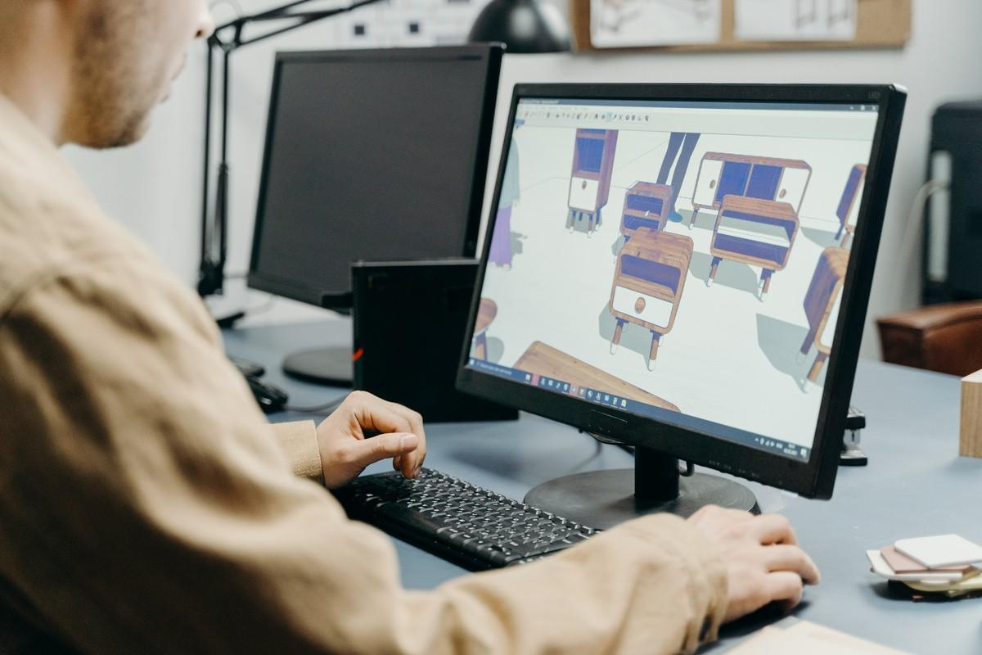

[Fig 3. Pexels (nd) , Interior Designer using](https://www.canva.com/photos/MAEbob5_PQM/) SketchUp

## Rhino (Rhinoceros 3D)

**Overview:** Rhino is known for its advanced modeling capabilities, especially for organic and complex shapes.

## Advantages:

Precise and flexible 3D modelling

Ideal for custom furniture or spatial elements Compatible with Grasshopper for parametric design

## Disadvantages:

Less intuitive than SketchUp

Requires additional plugins for rendering

**Industry Use:** Very useful for bespoke furniture design or other product design. Favoured in high- end and experimental interior design projects.

## Chief Architect

**Overview:** This software caters specifically to residential design, offering both 2D and 3D drawing capabilities.

## Advantages:

Tailored for interior and home design Realistic 3D renderings and walkthroughs Library of furnishings and interior elements

## Disadvantages:

Limited scalability for large commercial projects Not as customisable as other CAD tools

**Industry Use:** Often used by residential designers and decorators for client presentations and design development.

Digital drawing tools have revolutionised the interior design process, enabling professionals to present ideas with clarity, accuracy, and creative flair. Each software has its own strengths and is best suited to specific tasks within the design workflow. For instance, AutoCAD and Revit are crucial for detailed technical documentation, while SketchUp and Chief Architect are great for visualisation and client communication. Adobe tools help bridge the gap between design and presentation, and programs like Rhino open doors for innovative and custom solutions.

For interior design students and professionals alike, understanding these tools and choosing the right combination based on project needs is essential. As the industry continues to evolve, staying updated with these technologies will not only enhance workflow efficiency but also boost creativity and competitiveness in the design world.